` **CSC133**

**Chapter 4 processor and memory hands-on lab**

Note: Open your Lab system and Write down answers of following questions and attache screenshots wherever nesessary.

1. Which processor socket is installed on your lab machine?

LGA 775

2. which processor is installed on lab machine?

Intel Pentium 4 CPU 3.20 GHz

3. write down the type of processor socket (LGA or PGA)?

LGA

4. How many cores are there on processor and how many threads it can handle at a time?

Single core, multithreading capable ([doesn’t say how many threads](https://ark.intel.com/products/27500/Intel-Pentium-4-Processor-supporting-HT-Technology-3_20-GHz-1M-Cache-800-MHz-FSB))

5. List the three or more processor the board supports according to motherboard documentation or website.

Intel Pentium 4, Intel Pentium D, Intel Core 2 Duo, Intel Xeon, Intel Celeron

6. If your processor fails, which processor would you recommend for this system?

Xeon 3000-Series, or Intel Pentium 4

7. How much memory is installed? What is the name of memory installed?

4 GB DDR2 SDRAM

8. How many memory slots does the motherboard have? How many are populated?

4 Slots, 4 are Populated

9. Which channel your motherboard supports?

Dual Channel

If yes paste screenshot of first page and table of content:

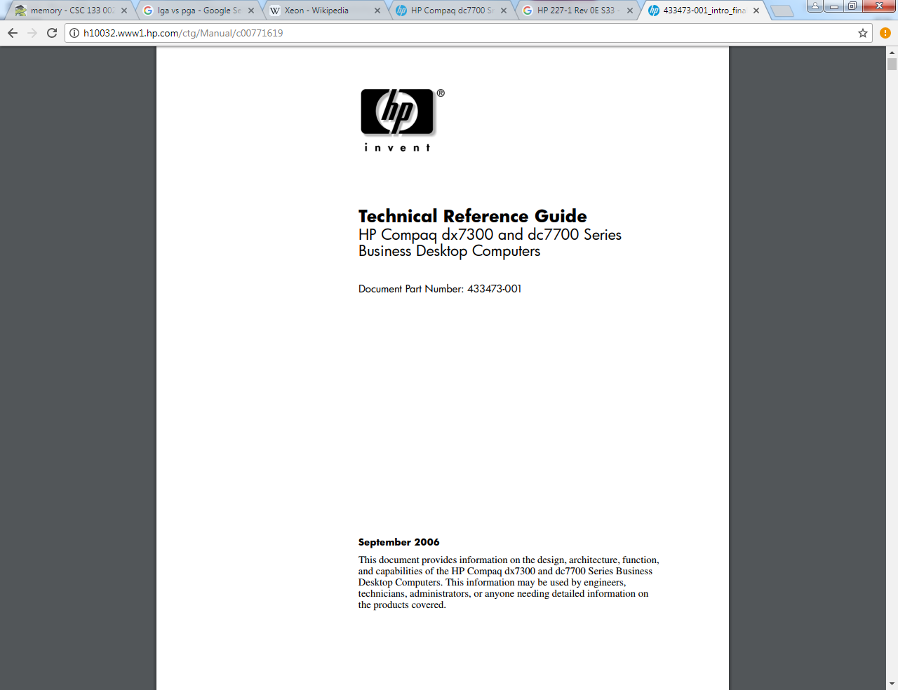

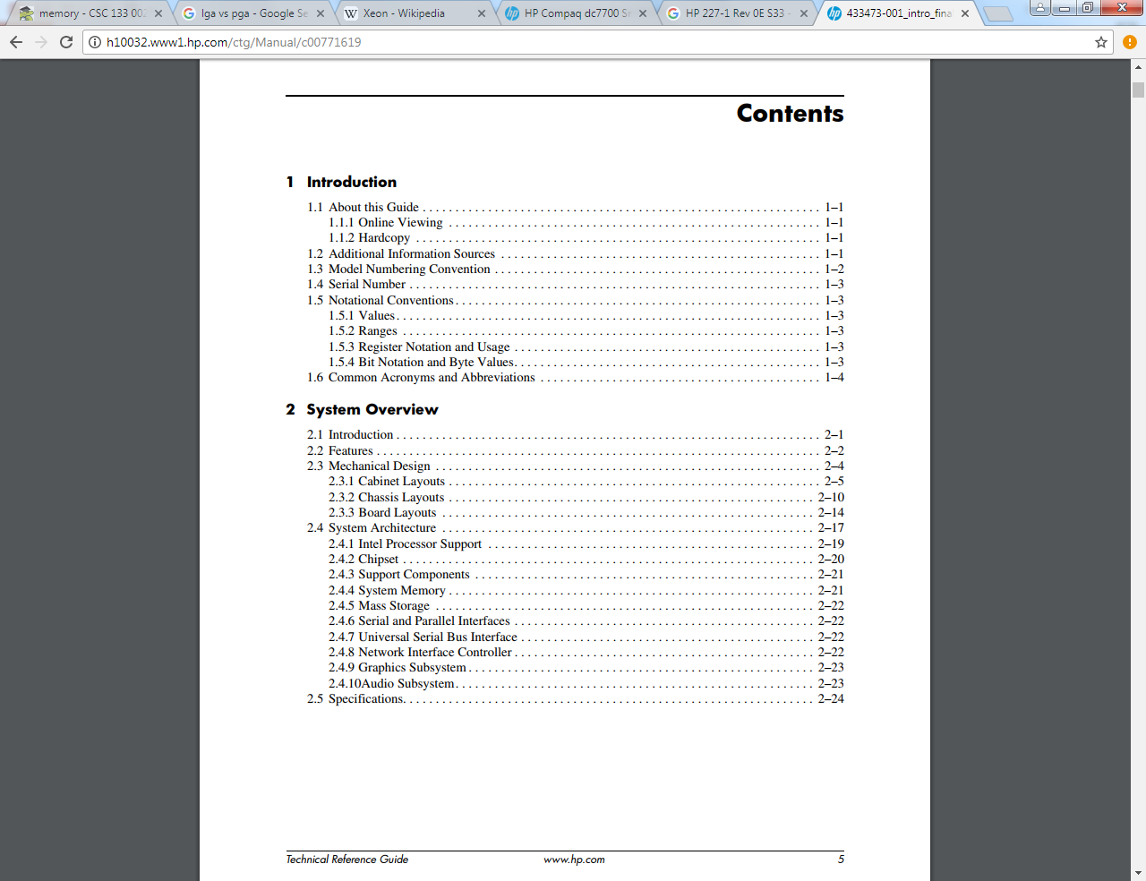

4. look for the service manual on internet.